OER Search Engines
- 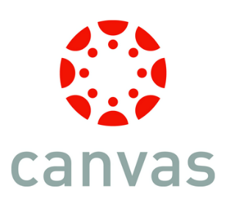
Canvas has a “commons” tool that enables the sharing, use, and modification of all types of educational material. Access to Canvas is contingent on institutional adoption, but can be accessed by private individuals for a fee.
- Creative Commons
Creative Commons is a nonprofit organization that enables the sharing and use of creativity and knowledge through free legal tools.
- Curriki Search
A nonprofit K-12 global community for teachers, students, and parents to create, share, and find free learning resources that enable true personalized learning.
- FREE: Federal Resources for Educational Excellence
More than 1,500 federally supported teaching and learning resources are included from dozens of federal agencies. New sites are added regularly.
- Google University Learning
"University Learning = OCW+OER = Free"
- Jorum
Jorum is a Jisc funded Service in Development in UK Further and Higher Education, to collect and share learning and teaching materials, allowing their reuse and repurposing.
more...
- MERLOT
List of over 2,200 open textbooks
- TEMOA
Tecnológico de Monterrey System
- Zunia
Index and search to OER sites and news.

OER Repositories and Aggregators
- AMSER: Applied Math and Science Educational Repository
Thousands of resources on the arts and sciences, free to use.
- Candela Open Courses
A catalog of open courses curated by Lumen Learning for Cerritos College. These courses can be adopted by departments at Cerritos College and added to TalonNet. Course content is multimedia. Once adopted, course content can be revised or changed by individual faculty members. If you're interested in adopting a course, contact support@lumenlearning.com
- Cerritos College OER Repository
Contains copies of OER textbooks and related materials that have been adopted by Cerritos College faculty. Materials can be downloaded from the site.
- Connexions
Textbooks, articles, supplements, learning resources for free online and free download. Can be copied and modified and reposted under your own name with attribution.
- Internet Archive
The Internet Archive is a non-profit that was founded to build an Internet library, it offers permanent access for researchers, historians, scholars, people with disabilities, and the general public to historical collections that exist in digital format.
- IUP-UNESCO List of OER Repositories
An extensive list of open and free educational materials.

- MERLOT
A portal to OER. "Find peer reviewed online teaching and learning materials. Share advice and expertise about education with expert colleagues. Be recognized for your contributions to quality education."

- MIT OpenCourseWare
Course materials for over 2000 courses available for free.
- OER Commons
Free to use learning and teaching content from around the world.
- Open Course Library
"The Open Course Library is a collection of expertly developed educational materials – including textbooks, syllabi, course activities, readings, and assessments – in 81 high-enrollment college courses. 42 courses have been completed so far, providing faculty with a high-quality, affordable option that will cost students no more than $30 for textbooks. All materials are shared under a Creative Commons (CC BY) license unless otherwise noted." Also available via Connexions.
- Open Courseware Consortium
"The OpenCourseWare Consortium is a collaboration of higher education institutions and associated organizations from around the world creating a broad and deep body of open educational content using a shared model."
- Zunia
Index and search to OER sites and news.

